PROJECT REPORT

on

VUTUBE

Submitted by

Binayak Singh
Roll No.:201500195

Kaustubh Dubey
Roll No.:201500332

Saksham Gangwar
Roll No.:201500603

Shreyash Varshney
Roll No.:201500675

Yogesh Kumar
Roll No.:201500833


Department of Computer Engineering & Applications
Institute of Engineering & Technology
GLA University
Mathura- 281406, U.P.
Declaration

I hereby declare that the work which is being presented in the Minor Project Report “Vutube”, in partial fulfillment of the requirements for Project is an authentic record of my own work carried under the supervision of Ms.Gurpreet Kaur, Assistant Professor, GLA University, Mathura.

Sign ______________________
Name of Candidate: Binayak Singh
University Roll No.:201500195

Sign ______________________
Name of Candidate: Kaustubh Dubey
University Roll No.: 201500332

Sign ______________________ Sign ______________________
Name of Candidate: Saksham Gangwar Name of Candidate:Shreyash Varshney
University Roll No:201500603 University Roll No:201500675

Sign ______________________
Name of Candidate: Yogesh Kumar
University Roll No.: 201500833

This is to certify that the above statements made by the candidate are correct to the best of my/our knowledge and belief.

_____________________

Project Supervisor
Ms.Gurpreet Kaur
Assistant Professor

Date:

Table of Contents
- Introduction | 1
1.1 Overview and Objective……………………………. | 5
- Project / Training Design | 2
2.1 Use Case Diagram……………………….…………. | 6
- System Requirements | 3
3.1 Software Required………………………………….. | 7
3.2 Hardware Required…………..……………………... | 7
- Implementation and User Interface | 4
4.1 Source Code……………………........ | 8-10
4.2 Components……………………..................................  4.3 Utils……………………………………………..... | 10-12  12-14
5. Conclusion  6. References | 15  16

CHAPTER-1
INTRODUCTION

The emergence of modern technologies has had profound impacts on the cinematic universe, with online video streaming now an integral part of the entertainment industry. The main advantages of online video streaming are flexibility and accessibility to watch content anywhere and anytime. People access to these platforms is no longer restricted to the hours of operation of cinema halls or network operators, but can be provided anytime and anywhere. Online video streaming is a well-established, and effective, entertainment method. However, there is a need for more empirical research to be directed toward investigating users’ experiences with online video streaming, their impact on there day to day life and there experience to this new form of experience. The purpose of this project is to develop a back-end application for online video streaming website using React technologies.

CHAPTER-2
USE CASE DIAGRAM

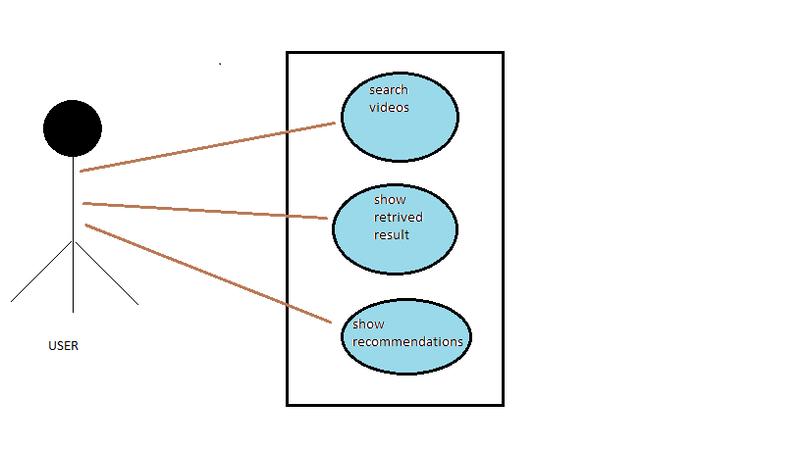

CHAPTER-3
SYSTEM REQUIREMENT

SOFTWARE AND HARDWARE REQUIREMENTS

- Windows 7+
- Processor Base Frequency of 1.8 GHz or higher
- 4 GB RAM or more
- 75 MB of available disk space or more
- Minimal screen resolution: 1366x768 pixels
- Camera and Mic (USB or Built in)

CHAPTER-4
IMPLEMENTATION

VUTUBE Project File Structure:
Here are the steps you will need to execute to build this project:
- First run the npx create-react-app in your terminal.
- Go to the package.json and include the needed dependencies in it.
- Now just run the npm –legacy-peer-dps to install all the required dependencies for the project.
- Now just go to the src file and work with App.js and index.js file.
- Then include the components folder to the src file where you will be including all the components of the project, so you just need to export it an use it at other location of the file.

Index.css
html,
body {
margin: 0;
padding: 0;
box-sizing: border-box;
}
a {
text-decoration: none;
color: black;
}
::-webkit-scrollbar {
width: 0px;
height: 5px;
}
::-webkit-scrollbar-thumb {
background-color: rgb(114, 113, 113);
border-radius: 10px;
height: 200px;
}
::-webkit-scrollbar-track {
background-color: transparent;
}
.category-btn:hover {
background-color: #FC1503 !important;
color: white !important;
}
.category-btn:hover span{
color: white !important;
}
.react-player {
height: 77vh !important;
width: 100% !important;
}
.search-bar{
border:none;
outline:none;
width:350px;
}
.category-btn{
font-weight: bold !important;
text-transform: capitalize;
display: flex;
align-items: center;
justify-content: start;
cursor:pointer;
background: transparent;
outline: none;
border: none;
padding: 7px 15px;
margin: 10px 0px;
border-radius: 20px;
transition: all 0.3s ease;
}
@media screen and (max-width: 900px) {
.category-btn{
margin: 10px;
}
}
@media screen and (max-width:800px){
.copyright{
display:none !important;
}
}
@media screen and (max-width: 600px) {
.scroll-horizontal {
overflow: auto !important;
}
.react-player {
height: 45vh !important;
}
.search-bar{
width:200px;
}
}

Index.js

import React from 'react';
import ReactDOM from 'react-dom/client';

import App from './App';
import './index.css';

const root = ReactDOM.createRoot(document.getElementById('root'));

root.render(<App />);

App.js

import { BrowserRouter, Routes, Route } from "react-router-dom";
import { Box } from '@mui/material';

import { ChannelDetail, VideoDetail, SearchFeed, Navbar, Feed } from './components';

const App = () => (
<BrowserRouter>
<Box sx={{ backgroundColor: '#000' }}>
<Navbar />
<Routes>
<Route exact path='/' element={<Feed />} />
<Route path='/video/:id' element={<VideoDetail />} />
<Route path='/channel/:id' element={<ChannelDetail />} />
<Route path='/search/:searchTerm' element={<SearchFeed />} />
</Routes>
</Box>
</BrowserRouter>
);

export default App;

Components
Navbar –

import { Stack } from "@mui/material";
import { Link } from "react-router-dom";
import { Typography} from "@mui/material";

import { logo } from "../utils/constants";
import { SearchBar } from "./";

const Navbar = () => (
<Stack direction="row" alignItems="center" p={2} sx={{ position: "sticky", background: '#000', top: 0, justifyContent: "space-between" }}>
<Link to="/" style={{ display: "flex", alignItems: "center" }}>
<img src={logo} alt="logo" height={45} />
</Link>
<SearchBar />
</Stack>
);

export default Navbar;

Searchbar –
import React, { useState } from 'react';
import { useNavigate } from "react-router-dom";
import { Paper, IconButton } from '@mui/material';
import SearchIcon from '@mui/icons-material/Search';

const SearchBar = () => {
const [searchTerm, setSearchTerm] = useState('');
const navigate = useNavigate();

const onhandleSubmit = (e) => {
e.preventDefault();

if (searchTerm) {
navigate(`/search/${searchTerm}`);

setSearchTerm('');
}
};

return (
<Paper
component='form'
onSubmit={onhandleSubmit}
sx={{
borderRadius: 20,
border: '1px solid #e3e3e3',
pl: 2,
boxShadow: 'none',
mr: { sm: 5 },
}}
>
<input
className='search-bar'
placeholder='Search...'
value={searchTerm}
onChange={(e) => setSearchTerm(e.target.value)}
/>
<IconButton type='submit' sx={{ p: '10px', color: 'red' }} aria-label='search'>
<SearchIcon />
</IconButton>
</Paper>
);
};

export default SearchBar;
Utils
Fetchfromapi.js –
import axios from 'axios';

export const BASE_URL = 'https://youtube-v31.p.rapidapi.com';

const options = {
params: {
maxResults: 50,
},
headers: {
'X-RapidAPI-Key': process.env.REACT_APP_RAPID_API_KEY,
'X-RapidAPI-Host': 'youtube-v31.p.rapidapi.com',
},
};

export const fetchFromAPI = async (url) => {
const { data } = await axios.get(`${BASE_URL}/${url}`, options);

return data;
};
Constant.js –
import MusicNoteIcon from '@mui/icons-material/MusicNote';
import HomeIcon from '@mui/icons-material/Home';
import CodeIcon from '@mui/icons-material/Code';
import OndemandVideoIcon from '@mui/icons-material/OndemandVideo';
import SportsEsportsIcon from '@mui/icons-material/SportsEsports';
import LiveTvIcon from '@mui/icons-material/LiveTv';
import SchoolIcon from '@mui/icons-material/School';
import FaceRetouchingNaturalIcon from '@mui/icons-material/FaceRetouchingNatural';
import CheckroomIcon from '@mui/icons-material/Checkroom';
import GraphicEqIcon from '@mui/icons-material/GraphicEq';
import TheaterComedyIcon from '@mui/icons-material/TheaterComedy';
import FitnessCenterIcon from '@mui/icons-material/FitnessCenter';
import DeveloperModeIcon from '@mui/icons-material/DeveloperMode';

export const logo = 'https://i.ibb.co/s9Qys2j/logo.png';

export const categories = [
{ name: 'New', icon: <HomeIcon />, },
{ name: 'Coding', icon: <CodeIcon />, },
{ name: 'ReactJS', icon: <CodeIcon />, },
{ name: 'NextJS', icon: <CodeIcon />, },
{ name: 'Music', icon: <MusicNoteIcon /> },
{ name: 'Education', icon: <SchoolIcon />, },
{ name: 'Podcast', icon: <GraphicEqIcon />, },
{ name: 'Movie', icon: <OndemandVideoIcon />, },
{ name: 'Gaming', icon: <SportsEsportsIcon />, },
{ name: 'Live', icon: <LiveTvIcon />, },
{ name: 'Sport', icon: <FitnessCenterIcon />, },
{ name: 'Fashion', icon: <CheckroomIcon />, },
{ name: 'Beauty', icon: <FaceRetouchingNaturalIcon />, },
{ name: 'Comedy', icon: <TheaterComedyIcon />, },
{ name: 'Gym', icon: <FitnessCenterIcon />, },
{ name: 'Crypto', icon: <DeveloperModeIcon />, },
];

export const demoThumbnailUrl = 'https://i.ibb.co/G2L2Gwp/API-Course.png';
export const demoChannelUrl = '/channel/UCmXmlB4-HJytD7wek0Uo97A';
export const demoVideoUrl = '/video/GDa8kZLNhJ4';
export const demoChannelTitle = 'Vutube';
export const demoVideoTitle = 'Well what is it for you to know.';
export const demoProfilePicture = 'http://dergipark.org.tr/assets/app/images/buddy_sample.png'

CHAPTER-5
CONCLUSION
While streaming services are becoming more popular, users are still gearing towards free streaming services like Youtube, which takes away the amount of revenue artists are making. However, streaming has proven to be beneficial for independent artists who are looking to get their name more known. Streaming has also been proven to be more convenient for consumer as it is faster and can be made available through any mobile device. Although streaming has caused a decrease in revenue for the video industry, the use of pirated video has declined, which was a major issue for the industry during the digital download era. Even more people are using free options of video streaming over paid subscriptions, the amount of revenue streaming services are earning is steadily increasing. Streaming is likely to be around for a while, but the video industry should be prepared for the next change in technology and the goal of this project is to make a video streaming website that provides free content ad free.

REFERENCES

- The Road to learn React by
- Robin Wieruch

- The Full Stack developer by
- Chris Northwood

- Modern Full Stack Development using React by
- Frank Zammetti

- Full stack Java Script by
- Azat Mardan

